## **Chapter 1**

## **INTRODUCTION**

#### **1.1 Background**

In the digital age, image editing has become an essential skill for various professions, including graphic design, photography, and web development. The demand for powerful and user-friendly image editing tools is ever-growing. This project aims to fulfill this need by developing an advanced image editing application using Python, Tkinter, and OpenCV. The application is designed to provide a comprehensive suite of image manipulation and enhancement features that cater to both novice and professional users.

Image editing has evolved from a niche skill to a mainstream necessity, driven by the increasing reliance on visual content in digital communication and marketing. Professionals and enthusiasts alike require tools that not only offer basic editing functionalities but also provide advanced capabilities for enhancing, manipulating, and analyzing images. This project aims to address these needs by creating an application that combines powerful image processing algorithms with an intuitive graphical user interface (GUI).

#### **1.2 Objectives**

The primary objective of this project is to develop a versatile image editing application that caters to both novice users seeking simplicity and professionals demanding advanced features. By leveraging OpenCV's extensive library of image processing functions and Tkinter's capability to create interactive and responsive GUIs, the application aims to provide a seamless user experience.

* **User-Friendly Interface**: The application will feature a clean, intuitive interface that simplifies complex image editing tasks. This ensures that users with minimal technical expertise can still utilize powerful image processing tools effectively.
* **Comprehensive Functionality**: Users will be able to perform a wide array of tasks, including basic adjustments such as resizing and rotating images, applying filters like grayscale and blur, and more complex operations such as face detection and histogram equalization.
* **Performance and Efficiency**: The application will be optimized for performance to ensure quick processing times, even for high-resolution images. Efficient memory management and processing algorithms will be employed to provide a smooth user experience.
* **Cross-Platform Compatibility**: Ensuring the application runs seamlessly across various operating systems (Windows, macOS, and Linux) is crucial. This enhances the tool's accessibility and usability for a broader audience.
* **Scalability and Extensibility**: The application's architecture will be designed to allow easy addition of new features and functionalities in the future, ensuring it can evolve with the changing needs of users.

#### **1.3 Significance and Context**

Image editing has become indispensable in the realm of digital communication, where visual content plays a pivotal role. From social media platforms to marketing campaigns, compelling images are essential for capturing and retaining audience attention. In this context, a powerful image editing tool is not just a luxury but a necessity.

* **Professional Use**: Graphic designers, photographers, and web developers require robust tools to create and manipulate images efficiently. The ability to quickly apply professional-grade edits can significantly impact the quality and appeal of their work.
* **Educational Use**: For students and educators in fields like digital media and computer science, an accessible image editing application provides a practical tool for learning and teaching image processing concepts.
* **Research and Development**: Researchers and developers working on projects involving computer vision and machine learning can benefit from a tool that allows them to preprocess and enhance images, facilitating more accurate and efficient model training.

### **Scope**

The scope of this project encompasses the design, development, and implementation of an image editing tool that integrates cutting-edge image processing techniques with a user-centric interface. The application will support functionalities essential for editing digital images, ensuring compatibility across multiple operating systems and accessibility through straightforward installation requirements.

* **Basic Image Editing**: Features like resizing, rotating, cropping, and adjusting brightness and contrast will be included, providing users with fundamental tools for everyday image editing tasks.
* **Advanced Image Processing**: Capabilities such as edge detection, histogram equalization, and face detection will be implemented using OpenCV's robust functions, offering users the ability to perform more sophisticated image manipulations.
* **User Interface Design**: The interface will be designed with usability in mind, ensuring that users can navigate and utilize the tool's features with ease. Tkinter will be used to create a responsive and interactive GUI.
* **Documentation and Support**: Comprehensive documentation will be provided to guide users through the installation and use of the application. Additionally, support for common issues and troubleshooting tips will be included.

## **Chapter 2**

## **SOFTWARE REQUIREMENT SPECIFICATION**

## **Functional Requirements**

### **1. Image Loading, Editing, and Saving**

#### **Description:**

The application should allow users to load images from various file formats, such as JPEG, PNG, and BMP. Once loaded, users should be able to perform editing operations and save the modified images back to the disk.

#### **Detailed Requirements:**

* **Load Image**:
  + Users should be able to select an image file from their system using a file dialog.
  + The application should support multiple file formats (e.g., JPEG, PNG, BMP).
* **Edit Image**:
  + Users should be able to resize images by specifying new dimensions.
  + Users should be able to rotate images by specified degrees.
  + Users should be able to flip images both horizontally and vertically.
* **Save Image**:
  + Users should be able to save modified images in the same or different file formats (e.g., JPEG, PNG).
  + Users should be able to define filenames and locations for saving the edited images.

### **2. Image Manipulation Operations**

#### **Description:**

The application should support a variety of image manipulation operations to enhance and modify images according to user preferences.

#### **Detailed Requirements:**

* **Filters**:
  + Users should be able to apply filters such as grayscale conversion, Gaussian blur, and edge detection to the loaded image.
* **Brightness and Contrast Adjustment**:
  + The application should allow users to adjust the brightness and contrast of images using sliders or input values.
* **Advanced Operations**:
  + Features like face detection using Haar cascades should be implemented.
  + Color inversion should be available to offer advanced image processing capabilities.

### **3. Performance and Responsiveness**

#### **Description:**

The application must perform efficiently even when handling high-resolution images or applying complex image processing algorithms.

#### **Detailed Requirements:**

* **Efficiency**:
  + Image processing tasks, such as applying filters or resizing images, should be performed in real-time or near real-time to provide a responsive user experience.
* **Memory Management**:
  + The application should handle memory efficiently to prevent crashes or slowdowns when processing large images or multiple images simultaneously.

## **Non-functional Requirements**

### **1. Usability and User Interface**

#### **Description:**

The user interface (UI) should be intuitive and easy to navigate, designed to minimize user effort in accessing and utilizing all features of the application.

#### **Detailed Requirements:**

* **GUI Design**:
  + Use Tkinter to create a visually appealing and responsive GUI that provides clear feedback on user actions and current image state.
* **Ease of Use**:
  + Provide tooltips, contextual help, and error messages to guide users in performing operations and troubleshooting issues.

### **2. Compatibility and Portability**

#### **Description:**

The application should be compatible with multiple operating systems (Windows, macOS, Linux) and should run seamlessly on different hardware configurations.

#### **Detailed Requirements:**

* **Cross-Platform Compatibility**:
  + Ensure that the application functions identically across different operating systems without requiring significant modifications.
* **Dependency Management**:
  + Use standard Python libraries and dependencies to minimize installation and execution issues across various platforms.

### **3. Reliability and Error Handling**

#### **Description:**

The application should handle errors gracefully and maintain reliability in executing tasks and processing image data.

#### **Detailed Requirements:**

* **Error Handling**:
  + Implement robust error handling mechanisms to catch and appropriately handle exceptions that may arise during image loading, processing, or saving.
* **Data Integrity**:
  + Ensure that image data integrity is maintained throughout operations, preventing corruption or loss of image quality during editing.

### **4. Security Considerations**

#### **Description:**

Ensure that the application does not compromise user data or system security during image processing and file operations.

#### **Detailed Requirements:**

* **File Handling Security**:
  + Implement secure file handling practices to prevent unauthorized access or modification of user files.
* **Data Privacy**:
  + Safeguard user data and ensure that sensitive information is not exposed or stored insecurely during image editing sessions.

**Chapter 3**

### **Project Description**

### **Overview**

The project aims to develop an advanced image editing application that leverages Python, Tkinter, and OpenCV to provide a comprehensive suite of image manipulation and enhancement features. This chapter provides a detailed description of the project's objectives, scope, methodology, and anticipated outcomes.

### **Objectives**

The primary objective of this project is to create a versatile and user-friendly image editing tool that meets the diverse needs of both novice users and professionals in fields such as graphic design, photography, and web development. Specific objectives include:

1. **Feature-Rich Functionality:** Implement essential image editing operations such as loading, saving, resizing, rotating, flipping, and applying filters (e.g., grayscale, blur, edge detection).
2. **Advanced Image Processing:** Integrate advanced capabilities like brightness and contrast adjustment, histogram equalization, face detection using Haar cascades, and colour inversion to cater to professional image editing requirements.
3. **User Interface Design:** Design an intuitive and responsive graphical user interface (GUI) using Tkinter, ensuring ease of navigation and accessibility of all functionalities.
4. **Cross-Platform Compatibility:** Ensure compatibility with major operating systems (Windows, macOS, Linux) to facilitate broad accessibility and usage across different environments.
5. **Performance Optimization:** Optimize image processing algorithms and memory management to ensure efficient performance, particularly when handling large image files or applying complex operations.

### **Scope**

The scope of the project encompasses several key components and functionalities that collectively contribute to the development of a robust image editing application:

1. **Image Loading and Saving:** Users will be able to load images from various file formats (e.g., JPEG, PNG, BMP) and save modified images in the same or different formats with customizable filenames and locations.
2. **Basic Image Editing Operations:** The application will support fundamental operations such as resizing images to specific dimensions, rotating by specified angles, and flipping horizontally or vertically.
3. **Image Filtering and Enhancement:** Users can apply a range of filters to enhance images, including grayscale conversion, Gaussian blur, edge detection for highlighting contours, and histogram equalization for improving contrast.
4. **Advanced Image Processing Features:** Advanced functionalities will include adjusting brightness and contrast levels dynamically, detecting faces in images using pre-trained Haar cascades, and inverting colors for creative effects.
5. **User Interface and Interaction:** The graphical user interface (GUI) will be designed with Tkinter to provide a visually appealing layout with interactive controls for seamless user interaction and feedback.
6. **Performance Considerations:** Efforts will be made to optimize the application’s performance, ensuring smooth execution of operations even with high-resolution images and intensive processing tasks.

### **Methodology**

The development methodology for this project will follow an iterative and incremental approach, integrating software engineering best practices to ensure quality and efficiency:

1. **Requirements Gathering:** Detailed gathering of functional and non-functional requirements through stakeholder consultations, market analysis, and user feedback surveys.
2. **Design Phase:** Creation of architectural designs, GUI wireframes, and algorithm specifications to map out the application's structure and user interface layout.
3. **Implementation:** Iterative coding and testing of modules using Python, OpenCV for image processing algorithms, and Tkinter for GUI development. Version control (e.g., Git) will be used to manage codebase changes and collaborations.
4. **Testing and Validation:** Rigorous testing will be conducted to verify functionality, usability, performance, and compatibility across different platforms and user scenarios. Unit testing, integration testing, and user acceptance testing (UAT) will be employed.
5. **Deployment and Maintenance:** Final deployment of the application, including documentation, user guides, and installation packages. Post-deployment support and maintenance will ensure ongoing updates, bug fixes, and feature enhancements based on user feedback and emerging requirements.

### **Anticipated Outcomes**

Upon completion, the project aims to deliver an advanced image editing application that sets a new standard in usability, functionality, and performance. Key anticipated outcomes include:

1. **User Satisfaction:** Positive user feedback indicating ease of use, efficiency in image editing tasks, and satisfaction with the application’s feature set.
2. **Market Impact:** Potential market recognition and adoption among professionals in graphic design, photography, and related fields seeking a reliable and feature-rich image editing solution.
3. **Educational Value:** Contribution to educational resources and learning materials for Python programming, GUI development with Tkinter, and image processing techniques using OpenCV.
4. **Future Development:** A solid foundation for future enhancements, including integration with cloud services, additional image processing algorithms, and support for emerging technologies.

**Chapter 4**

**Project Code**

The project code provides a comprehensive image editing application using Tkinter for the graphical user interface and OpenCV for image processing. The application offers various functionalities, including loading and saving images, applying filters, resizing, rotating, and more. This chapter explains the code structure and the functionalities implemented.

Importing necessary libraries and setting up global variables:

|  |
| --- |
| import cv2  import tkinter as tk  from tkinter import filedialog, messagebox, Scale  from PIL import Image, ImageTk  # Initialize a stack to keep track of image states for undo functionality  image_stack = [] |

**cv2**: OpenCV library for image processing.

**tkinter**: Standard Python interface to the Tk GUI toolkit.

**PIL (Python Imaging Library)**: Used for image processing and creating a Tkinter-compatible image format.

**Loading and Displaying Images**:

|  |
| --- |
| def load_image():  global img, img_display, img_display_original, image_path, original_img  image_path = filedialog.askopenfilename()  if image_path:  img = cv2.imread(image_path)  if img is not None:  image_stack.clear()  image_stack.append(img.copy())  original_img = img.copy()  display_image(img)  display_original_image(img)  adjust_window_size(img.shape[1], img.shape[0])  else:  messagebox.showerror("Error", "Could not open or find the image.")  else:  messagebox.showwarning("Warning", "No file selected.") |

* **load_image()**: Opens a file dialog to select an image. Reads the image using OpenCV and updates the global variables. Adds the image to the stack for undo functionality and displays the image using display_image().

**Displaying Images**:

|  |
| --- |
| def display_image(img):  img_rgb = cv2.cvtColor(img, cv2.COLOR_BGR2RGB)  img_pil = Image.fromarray(img_rgb)  img_tk = ImageTk.PhotoImage(img_pil)  img_display.config(image=img_tk)  img_display.image = img_tk |

* **display_image()**: Converts an OpenCV image (BGR format) to an RGB image, then to a PIL image, and finally to an ImageTk format suitable for displaying in Tkinter. Updates the img_display label to show the image.

**Resizing and Rotating Images**:

|  |
| --- |
| def resize_image():  global img  try:  width = int(entry_width.get())  height = int(entry_height.get())  img_resized = cv2.resize(img, (width, height))  image_stack.append(img_resized.copy())  display_image(img_resized)  img = img_resized  adjust_window_size(width, height)  except ValueError:  messagebox.showerror("Error", "Please enter valid dimensions.")  def rotate_image():  global img  try:  angle = int(entry_rotate.get())  (h, w) = img.shape[:2]  center = (w // 2, h // 2)  M = cv2.getRotationMatrix2D(center, angle, 1.0)  img_rotated = cv2.warpAffine(img, M, (w, h))  image_stack.append(img_rotated.copy())  display_image(img_rotated)  img = img_rotated  adjust_window_size(img.shape[1], img.shape[0])  except ValueError:  messagebox.showerror("Error", "Please enter a valid rotation angle.") |

* **resize_image()**: Resizes the image to the specified width and height. Updates the stack and displays the resized image.
* **rotate_image()**: Rotates the image by the specified angle. Computes the rotation matrix and applies it to the image using cv2.warpAffine(). Updates the stack and displays the rotated image.

**Applying Filters**:

|  |
| --- |
| def apply_grayscale():  global img  img_gray = cv2.cvtColor(img, cv2.COLOR_BGR2GRAY)  img_display_gray = cv2.cvtColor(img_gray, cv2.COLOR_GRAY2RGB)  image_stack.append(img_display_gray.copy())  display_image(img_display_gray)  img = img_gray  def apply_blur():  global img  img_blur = cv2.GaussianBlur(img, (15, 15), 0)  image_stack.append(img_blur.copy())  display_image(img_blur)  img = img_blur  def apply_edge_detection():  global img  img_edges = cv2.Canny(img, 100, 200)  img_display_edges = cv2.cvtColor(img_edges, cv2.COLOR_GRAY2RGB)  image_stack.append(img_display_edges.copy())  display_image(img_display_edges)  img = img_edges |

* **apply_grayscale()**: Converts the image to grayscale using cv2.cvtColor(). Updates the stack and displays the grayscale image.
* **apply_blur()**: Applies a Gaussian blur filter to the image. Updates the stack and displays the blurred image.
* **apply_edge_detection()**: Applies edge detection using the Canny algorithm. Converts the result to RGB for display in Tkinter, updates the stack, and displays the edges.

**Adjusting Brightness and Contrast**:

|  |
| --- |
| python  Copy code  def adjust_brightness_contrast(brightness=0, contrast=100):  global img, original_img  img = original_img.copy()  beta = brightness  alpha = contrast / 100.0  img_adjusted = cv2.convertScaleAbs(img, alpha=alpha, beta=beta)  display_image(img_adjusted) |

* **adjust_brightness_contrast()**: Adjusts the brightness and contrast of the image. Uses cv2.convertScaleAbs() to apply the adjustments and displays the adjusted image.

**Undo Functionality**:

|  |
| --- |
| def undo():  global img  if len(image_stack) > 1:  image_stack.pop()  img = image_stack[-1].copy()  display_image(img)  adjust_window_size(img.shape[1], img.shape[0])  else:  messagebox.showwarning("Warning", "No more states to undo.") |

* **undo()**: Reverts the image to the previous state by popping the top of the stack. Displays the previous state and adjusts the window size accordingly.

**Chapter 4**

# **Snapshots**

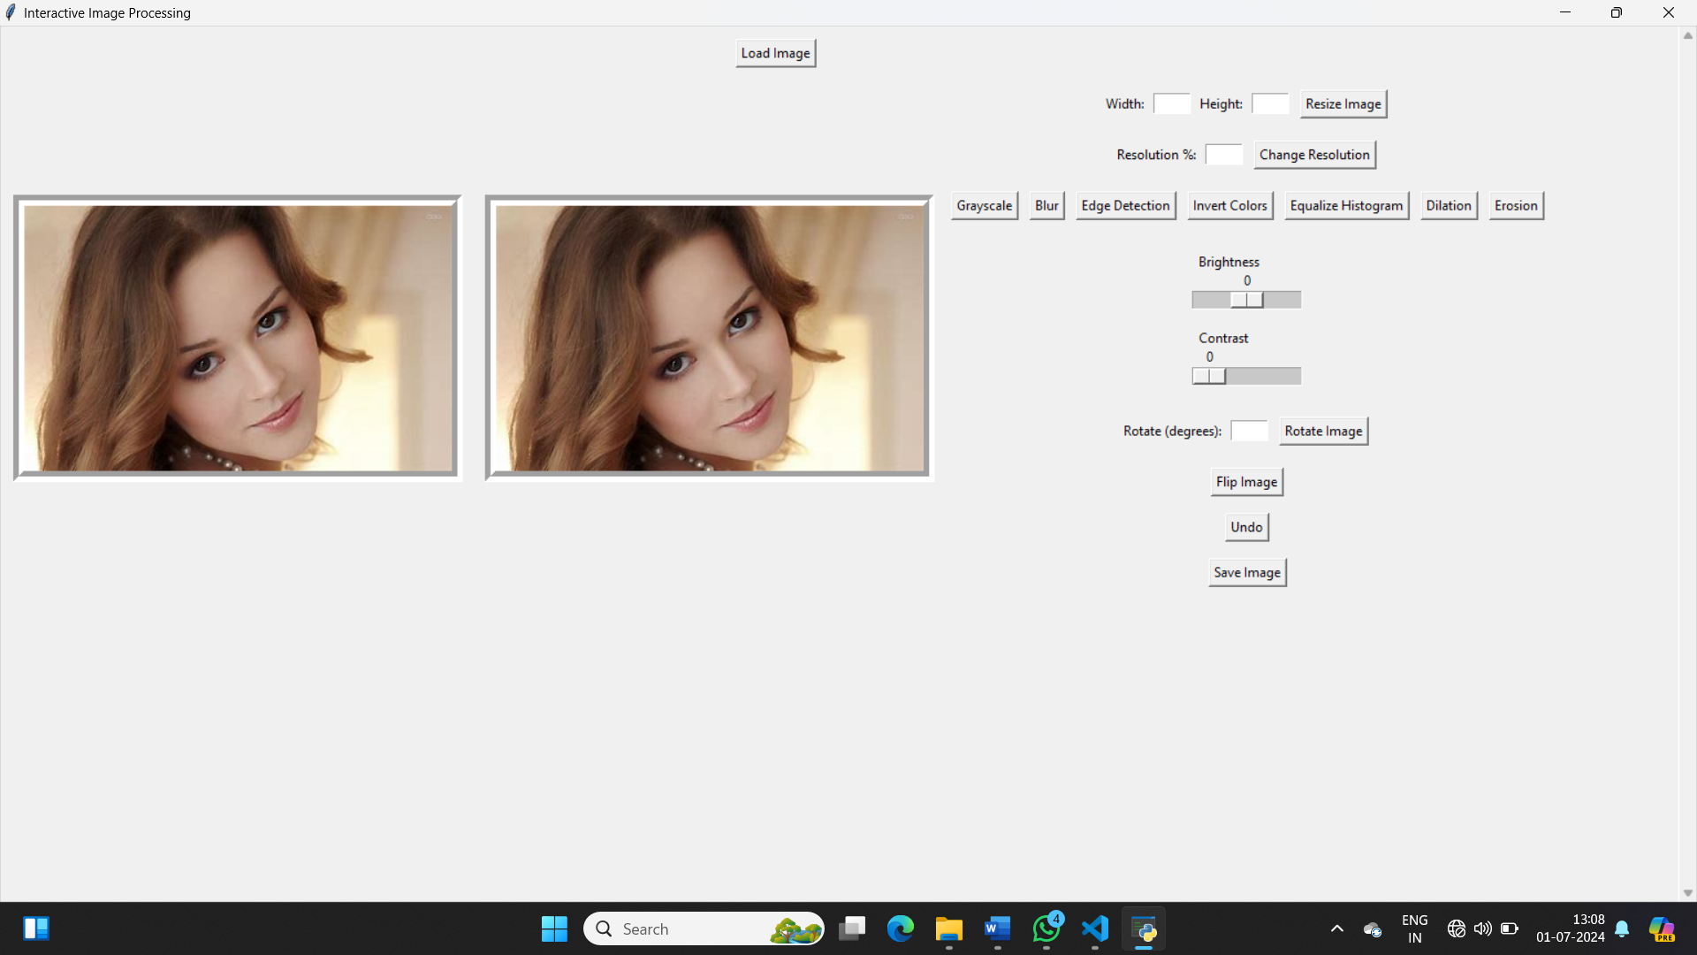

**Fig: loading the image**

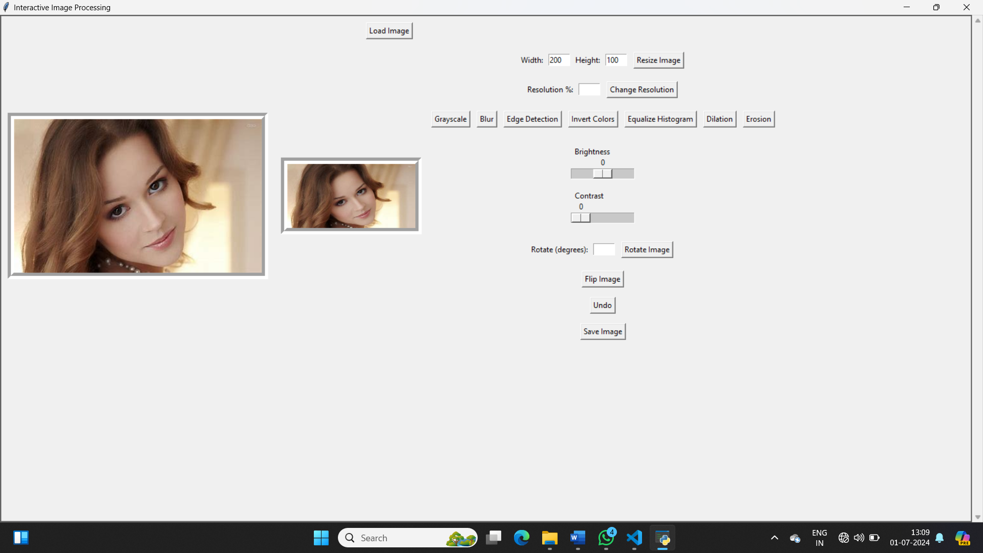

**Fig: Resize the image**

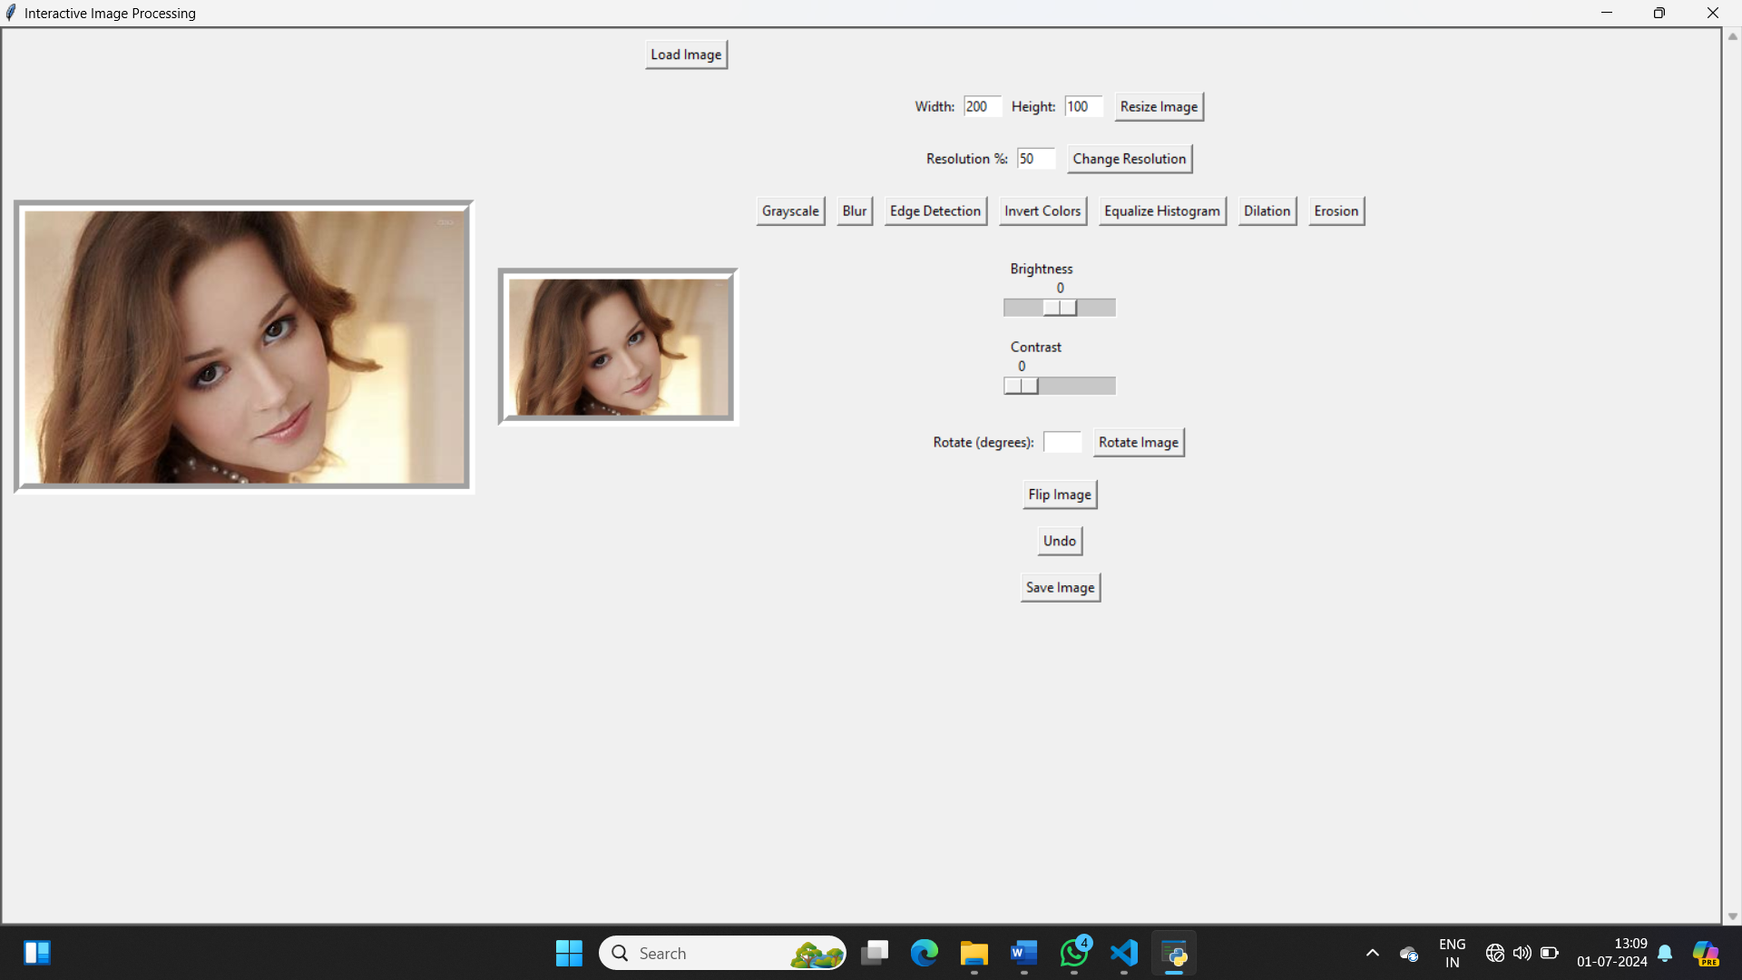

**Fig: Changing The Resolution the image**

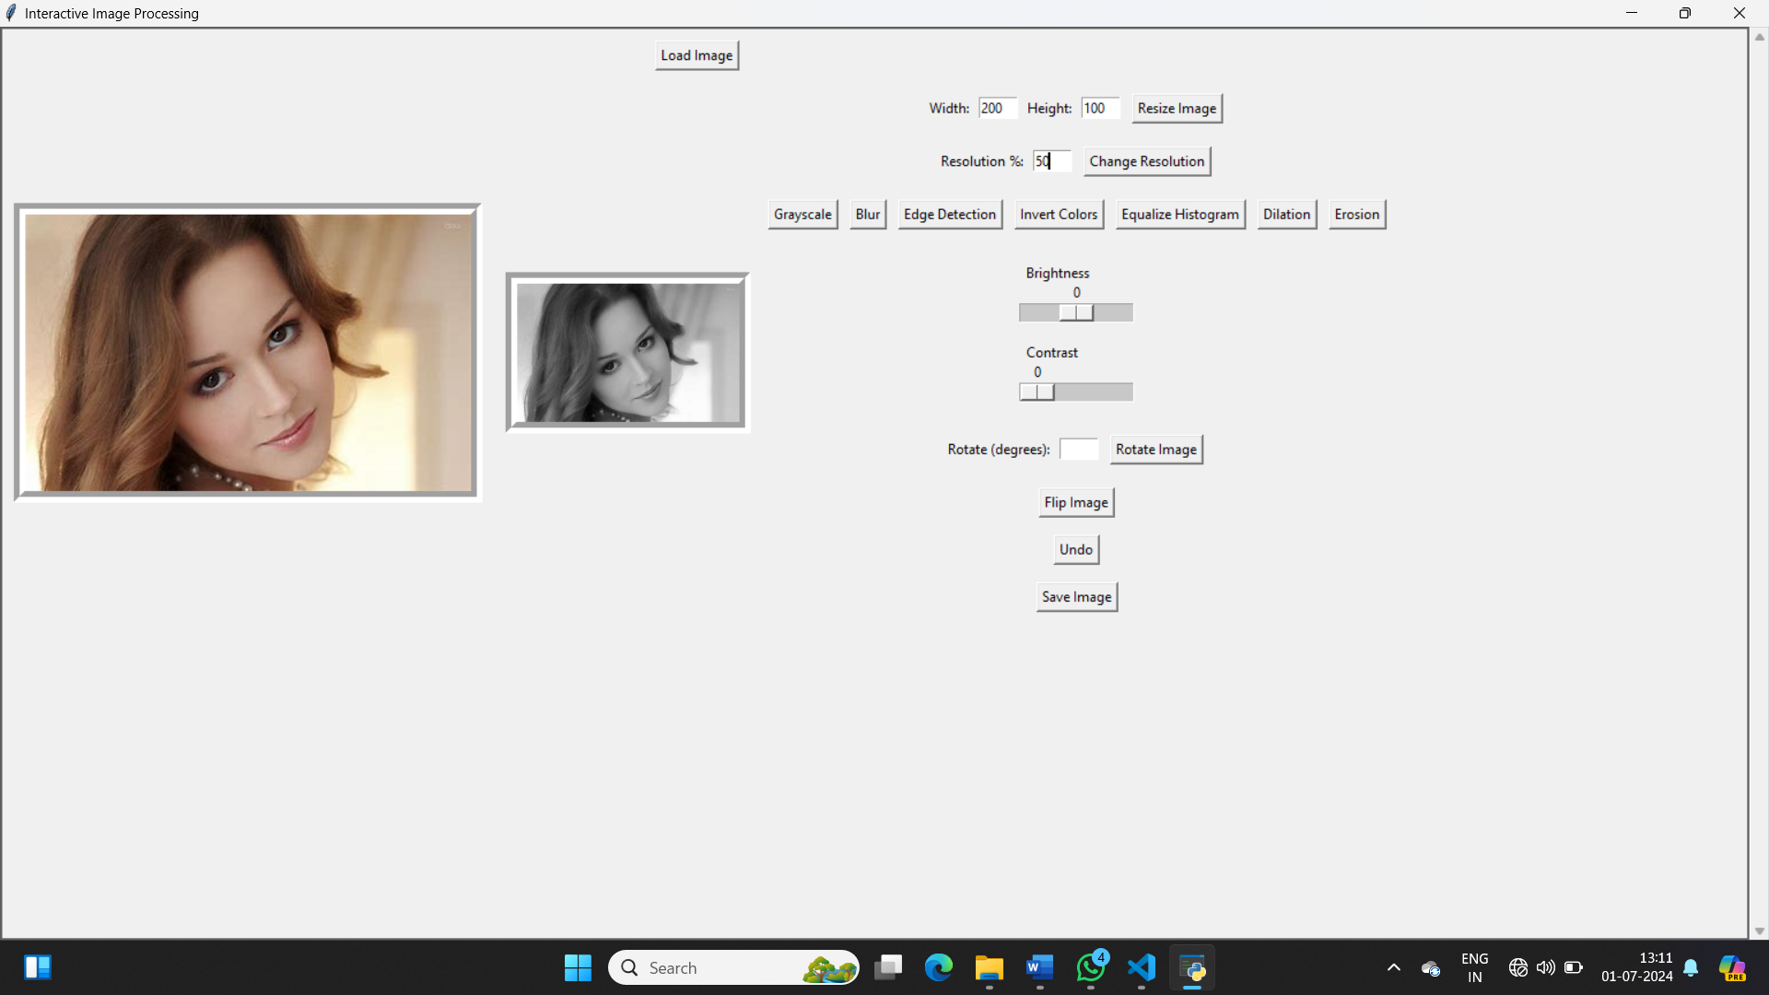

**Fig: Grayscale The Resolution the image**

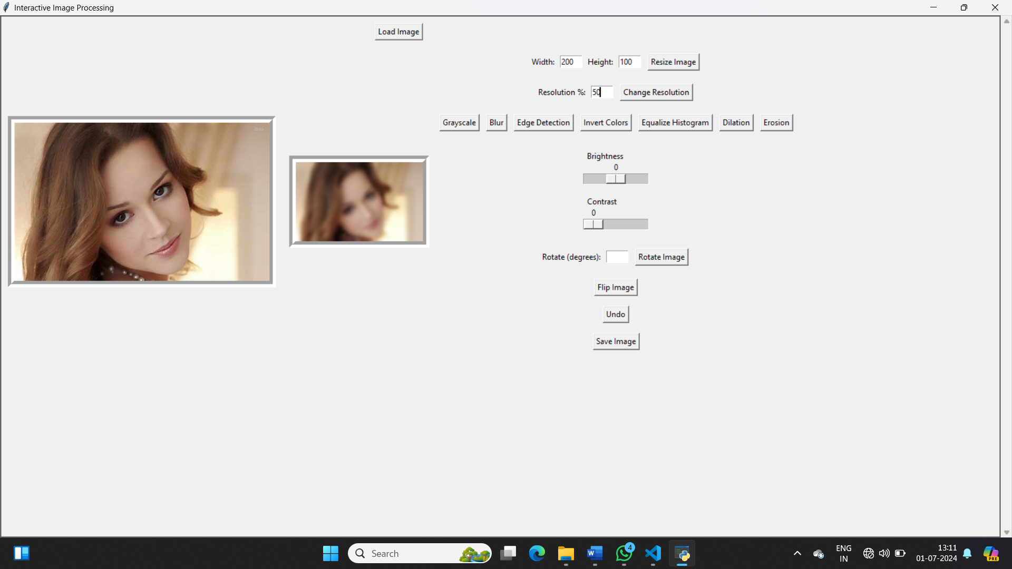

**Fig: Changing The Resolution the image**

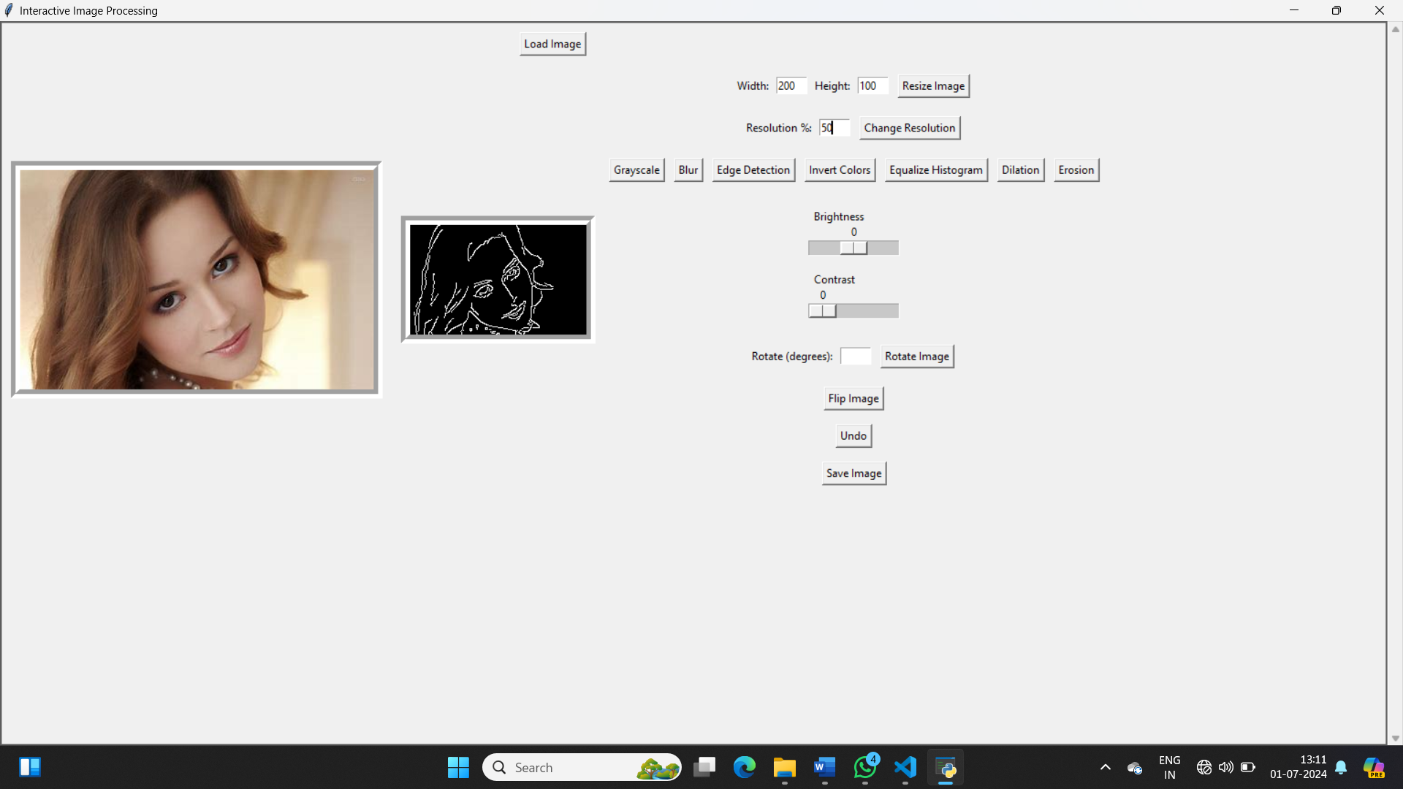

**Fsig: Edge detection**

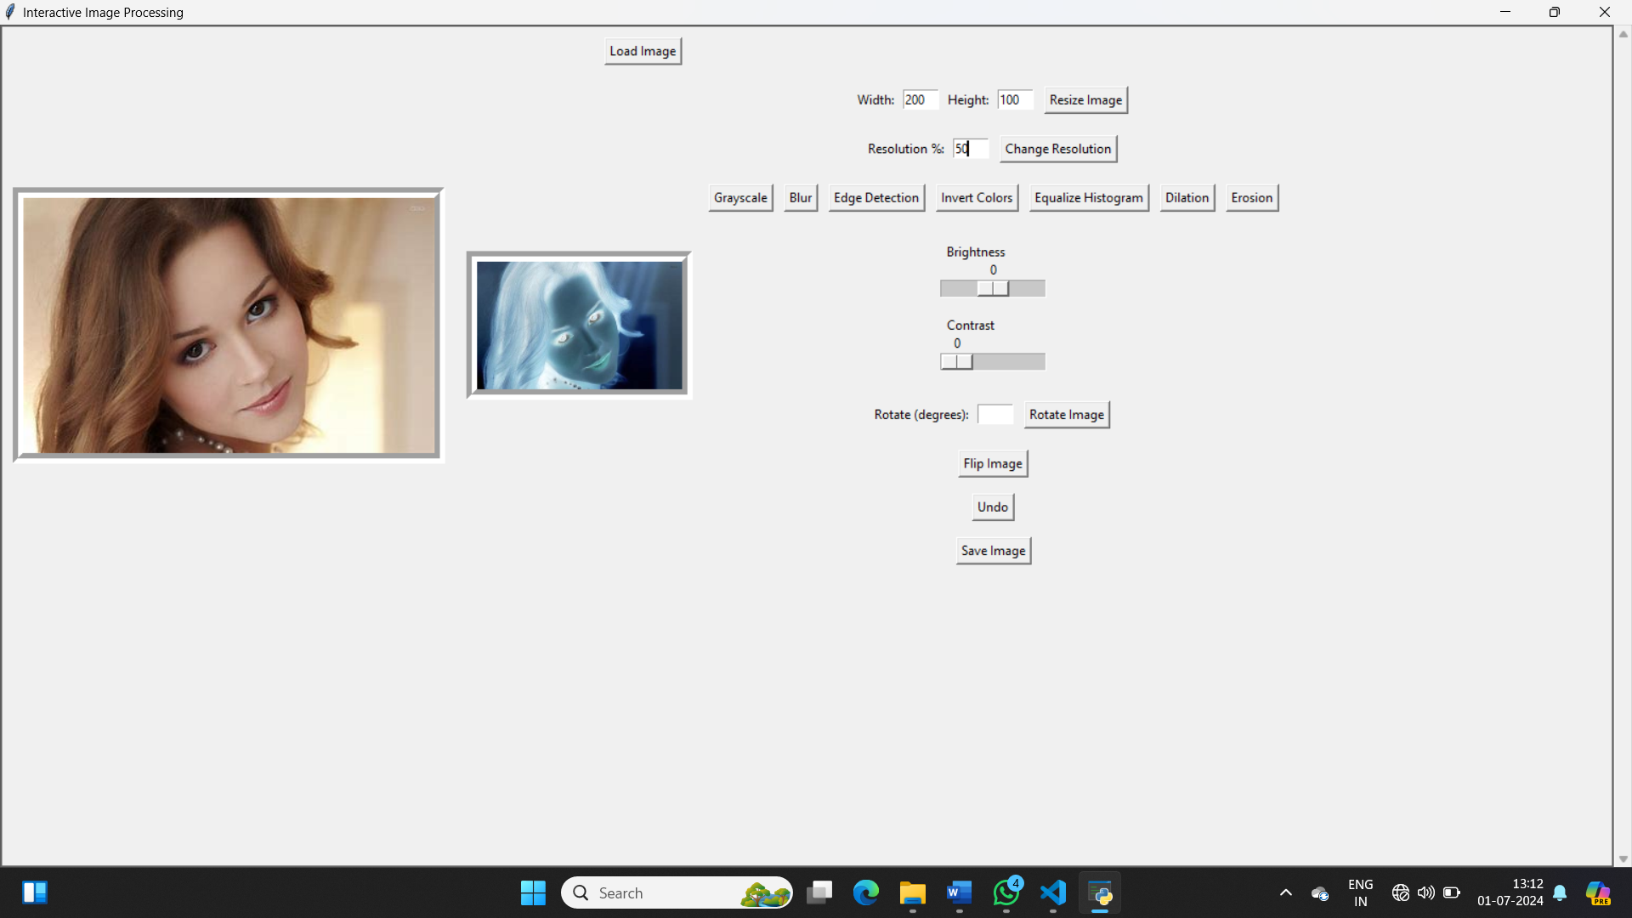

**Fig: Invert colours**

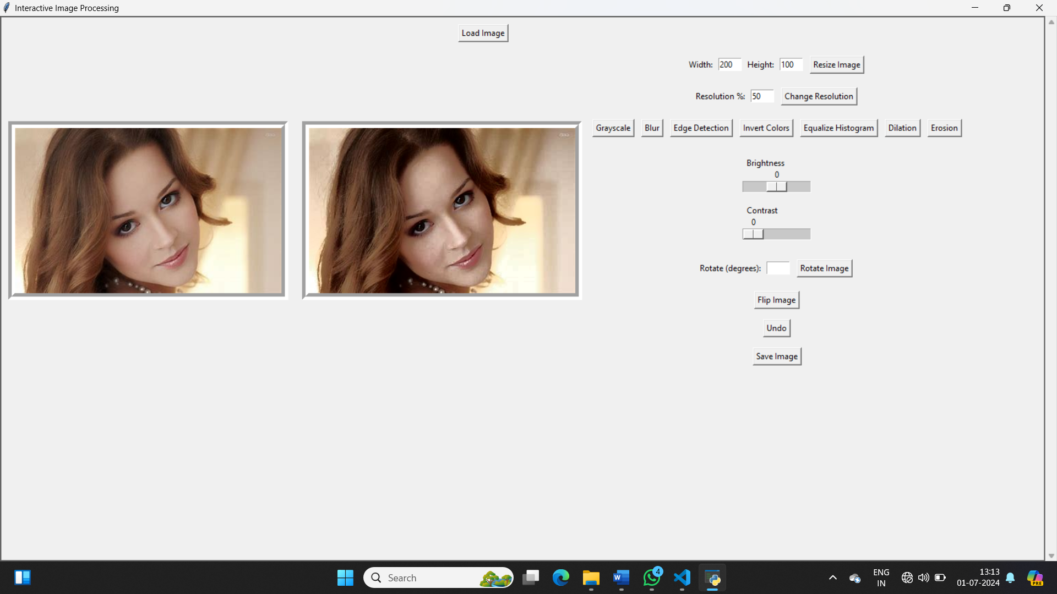

**Fig: Equalize Histogram**

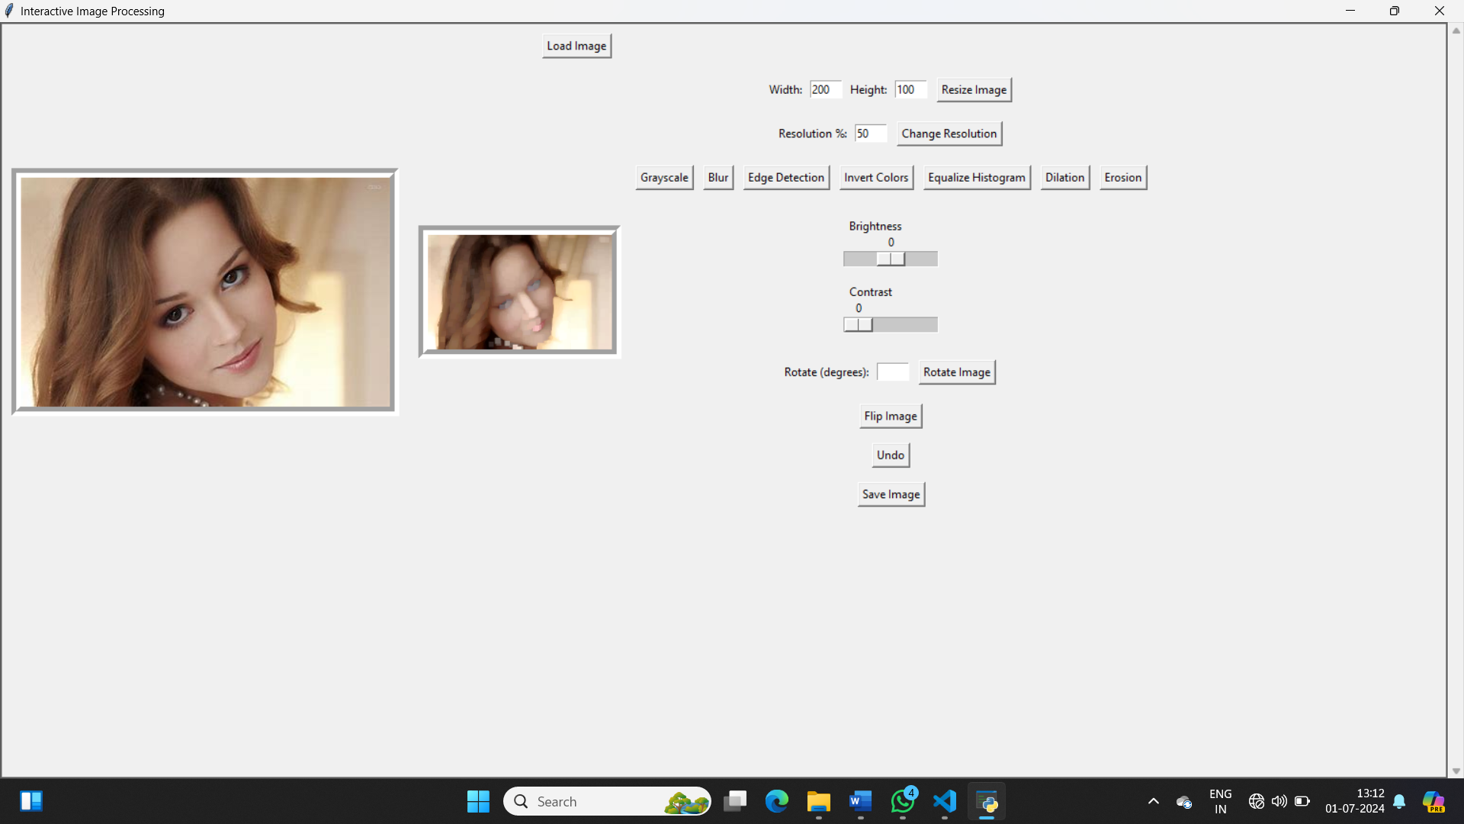

**Fig: Dilation**

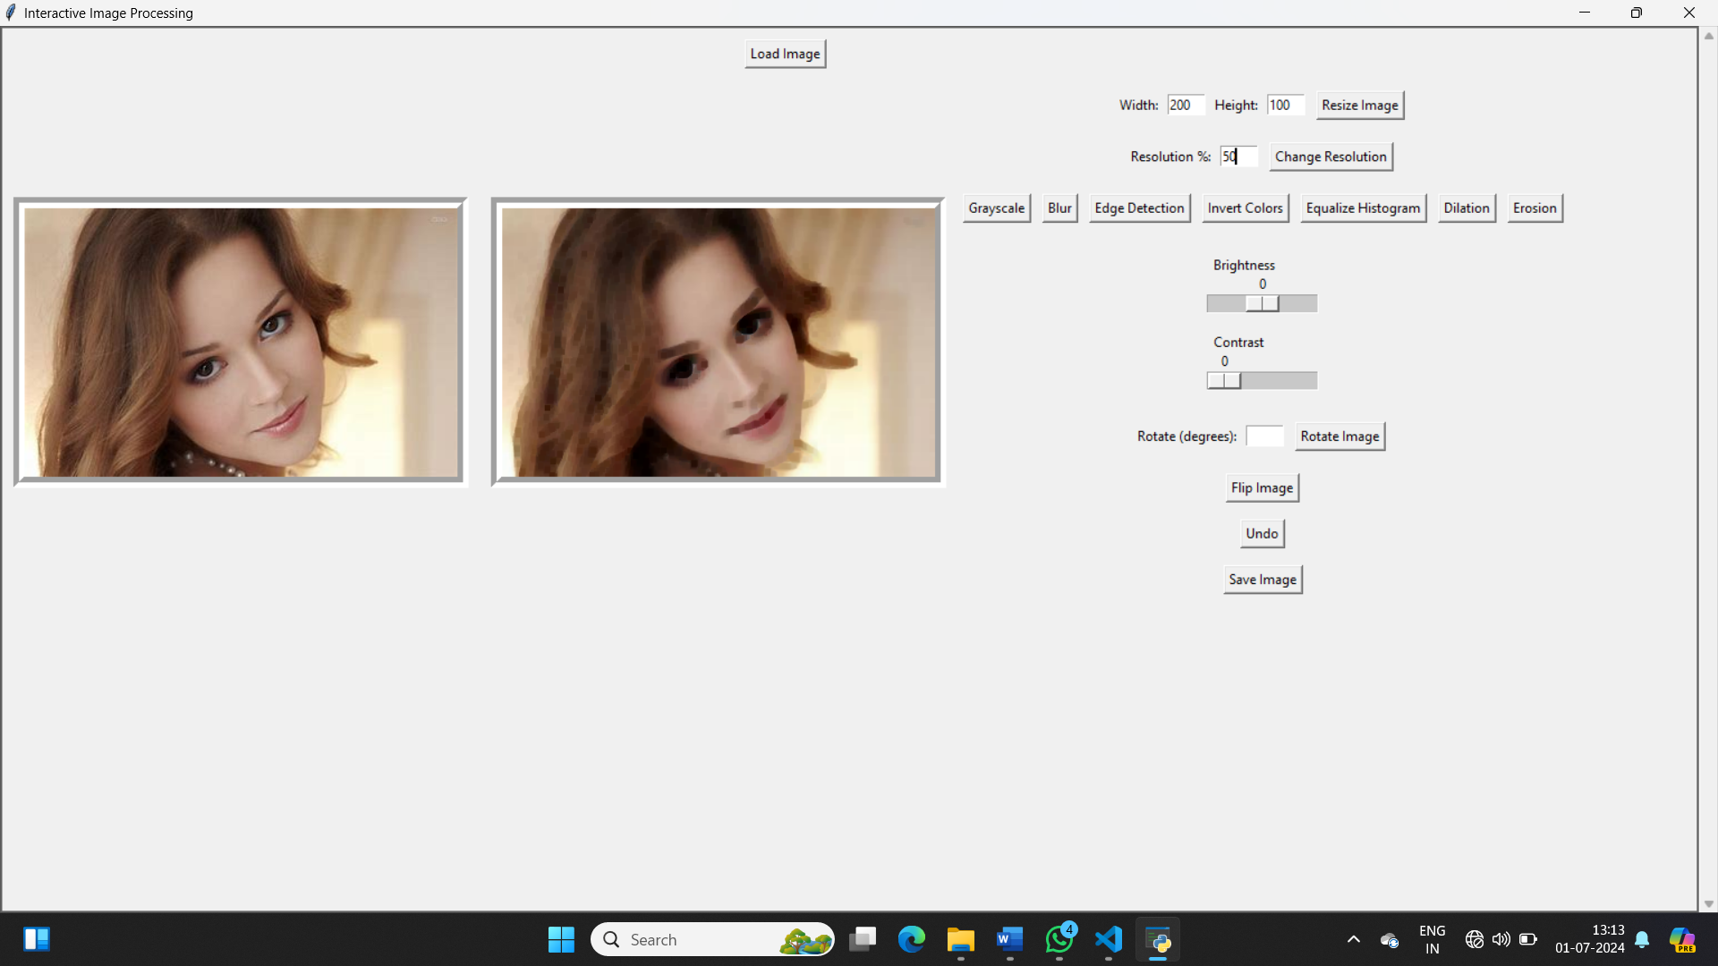

**Fig: Erosion**

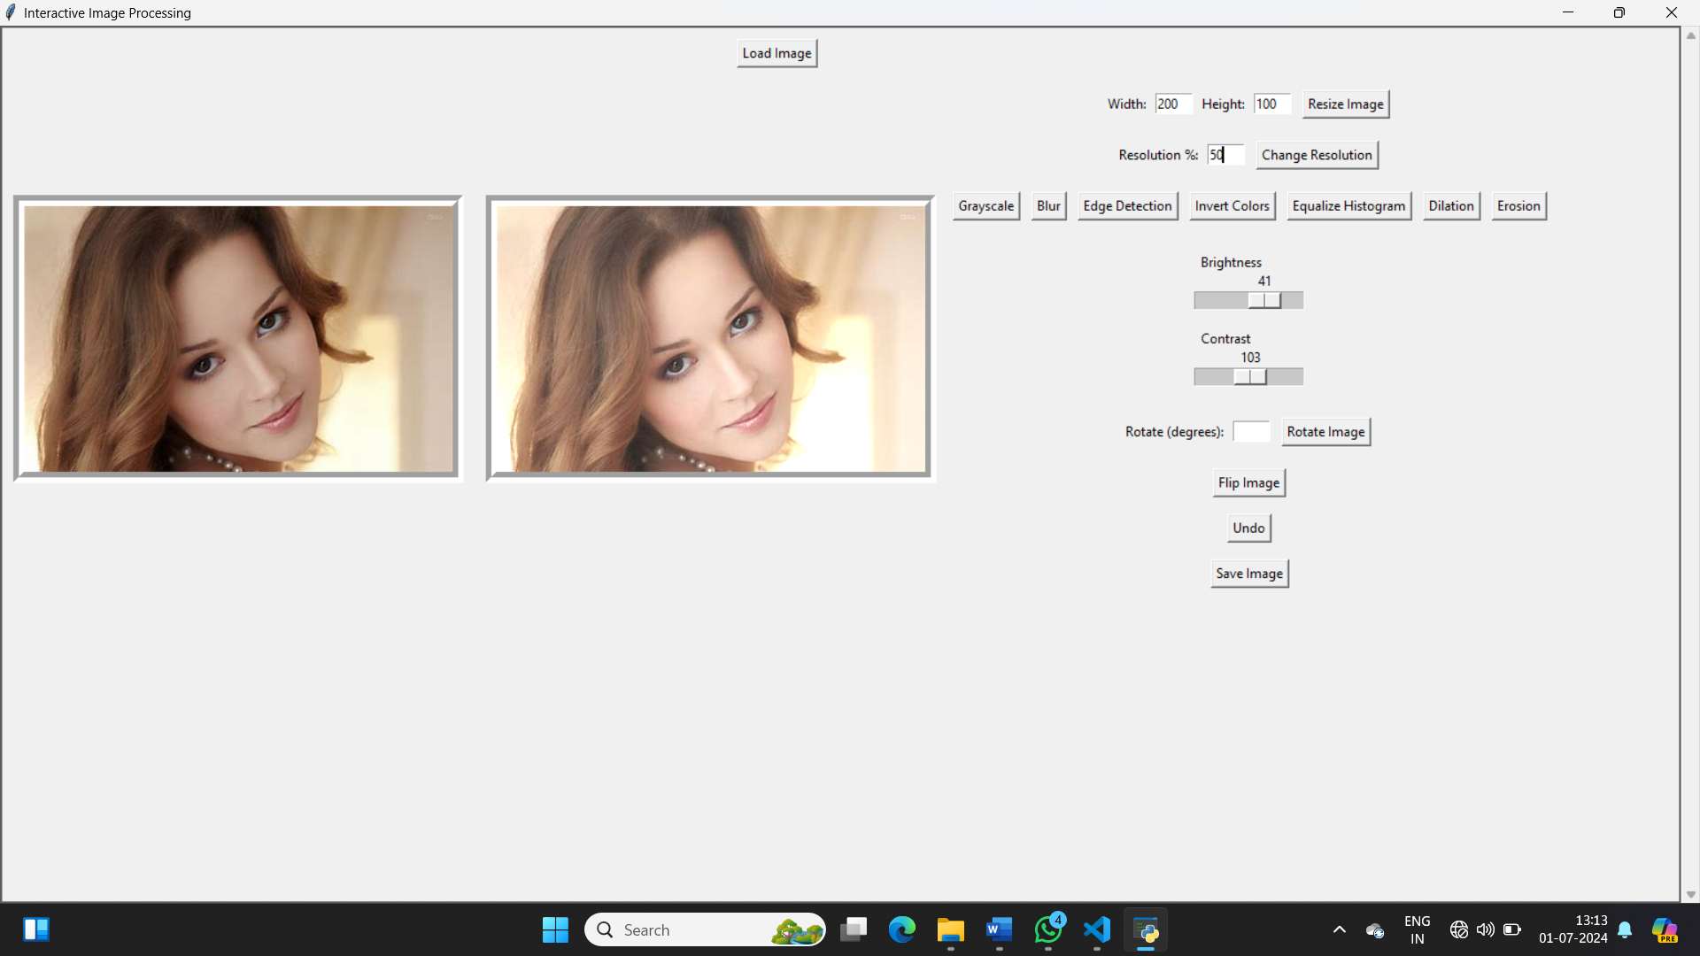

**Fig: Brightness and Contrast**

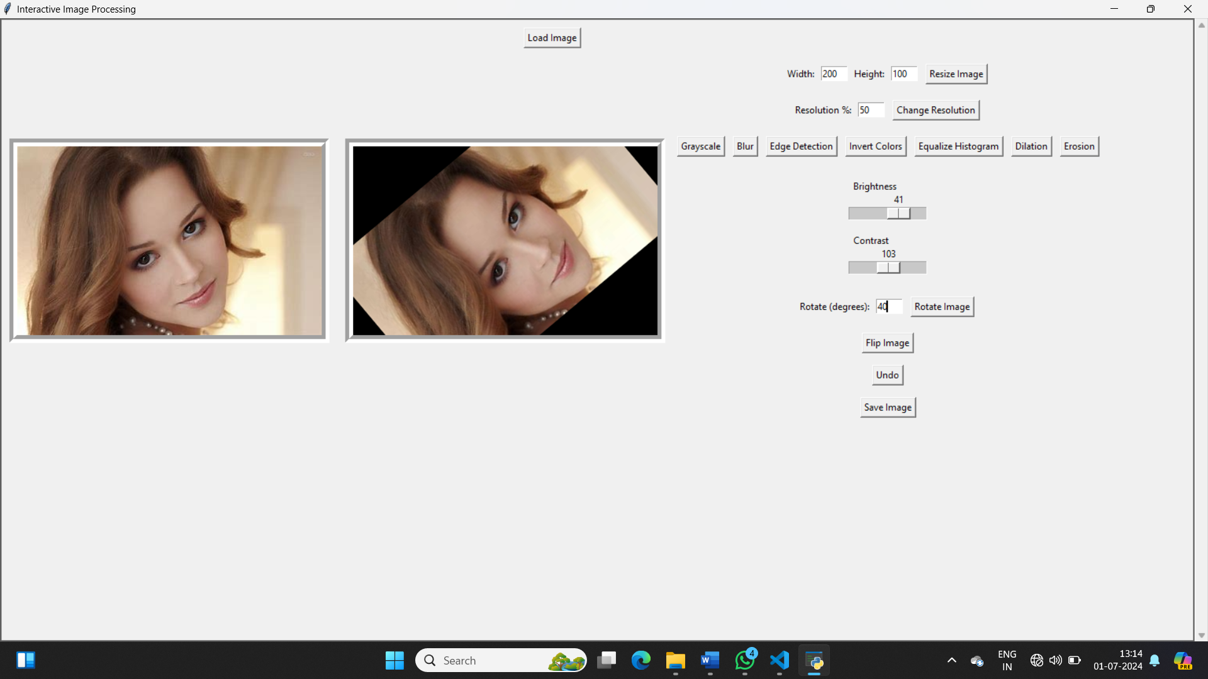

**Fig: Rotation**

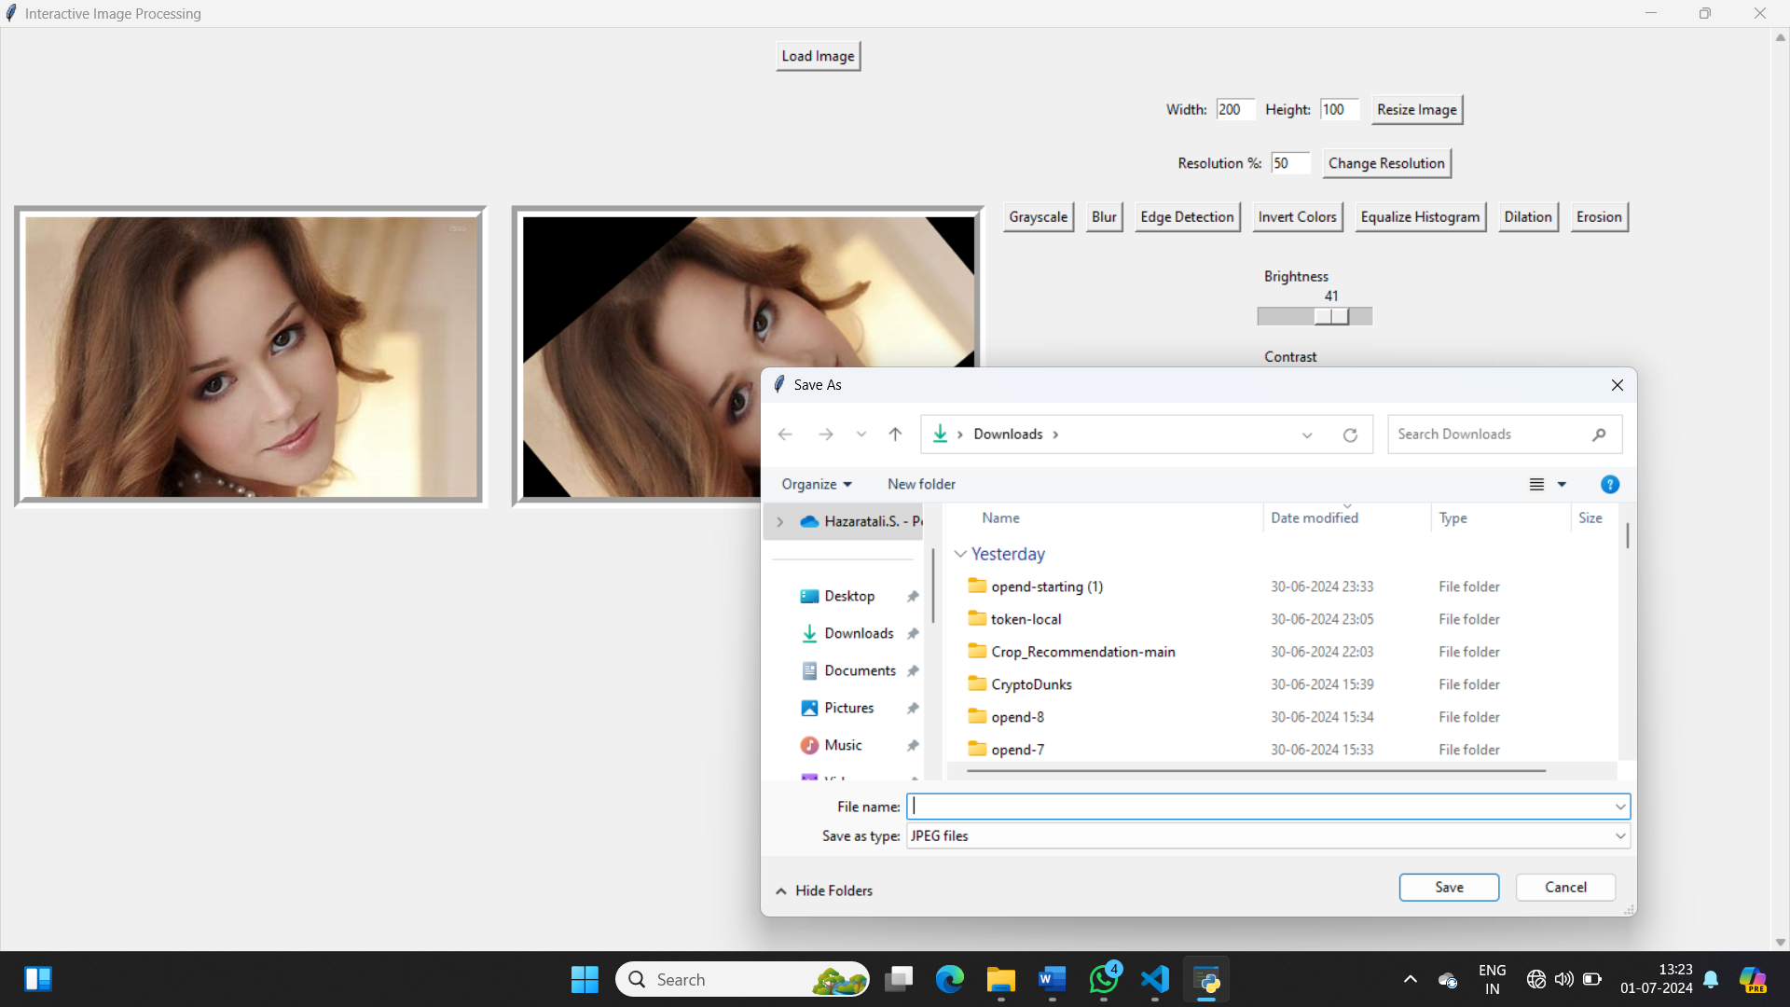

**Fig: Saving the images**

## **CONCLUSION**

The Interactive Image Processing project effectively combines OpenCV's image processing capabilities with Tkinter's user-friendly interface, creating a versatile and intuitive tool for various image editing tasks. Users can resize, rotate, apply filters, and adjust brightness and contrast, all within a cohesive application. The user-friendly interface and real-time feedback make the tool accessible to users of all experience levels. Key features include a comprehensive range of editing functions, undo functionality using a stack-based approach, and robust error handling for user inputs and file operations.

Challenges such as efficient image data handling and ensuring a responsive design were successfully addressed. Future enhancements could include additional filters, batch processing capabilities, and integration with other libraries like scikit-image to introduce advanced image processing techniques, further enhancing the tool's functionality and appeal.

## **REFERENCE**

### **References**

[1]. **OpenCV Documentation:** Essential for understanding and implementing various image processing techniques. OpenCV Documentation

[2]. **Tkinter Documentation:** Crucial for designing and implementing the graphical user interface.

[3]. **Pillow Documentation:** Key for handling and manipulating image files.

[4]. **Real Python:** Provided practical tutorials and guides on using Python libraries, including OpenCV and Tkinter.

[5]. **Stack Overflow:** Invaluable for troubleshooting and finding coding solutions.

[6]. **GeeksforGeeks:** Offered detailed guides on OpenCV and Tkinter

[7]. **Python.org:** Key resource for general Python programming concepts and best practices.

[8]. **Digital Image Processing by Gonzalez and Woods:** Provided an in-depth understanding of image processing fundamentals.

* Gonzalez, R. C., & Woods, R. E. (2018). Digital Image Processing (4th ed.). Pearson.

[9]. **Learning OpenCV 4 Computer Vision with Python by Howse and Minichino:** Practical examples and explanations of OpenCV functionalities.

* Howse, J., & Minichino, J. (2020). Learning OpenCV 4 Computer Vision with Python (3rd ed.). Packt Publishing.

[10]. **Programming Computer Vision with Python by Solem:** Valuable insights and practical examples in computer vision and image processing. - Solem, J. E. (2012). Programming Computer Vision with Python: Tools and algorithms for analyzing images. O'Reilly Media.